**Khulna University of Engineering & Technology**

Department of Computer Science and Engineering



SYSTEM DEVELOPMENT PROJECT

CSE 3200

**“Fingerprint Based Biometric Attendance System”**

By

**Projapoti Roy**

Roll: 1607041

&

**Sharia Wasika Aditi**

Roll: 1607109

**Supervisor:**

**Prottoy Saha**

Lecturer

Department of Computer Science and Engineering

Khulna University of Engineering & Technology

______________________

Supervisor’s Signature

**Acknowledgement:**

The first thank is to the Almighty creator who has permitted and blessed us to carry out this project and without whose instruction nothing was possible and it was a supreme favor of God.

Here we want to express our sincere and core heart gratitude to our respectful Supervisor Pottoy Saha, Lecturer, Department of Computer Science and Engineering, Khulna University of Engineering & Technology for his relentless patience, constant inspiration and friendly guidance during the

progress of the work. Without his help and suggestion it was not possible anyway to complete the work. We are also humbly grateful to all our reverent teachers of our department for their support.

**Abstract:**

In this project, the design and development of Biometric Attendance System based on fingerprint is presented. The project consists of three stages namely ‘enrollment’, ‘attendance’ & ‘data storage’. The method of enrolling fingers and recording attendance is done with the help of fingerprint module. Using SD Card module the attendance details of a student are saved in a file**.** Rather than recording the attendance in writing or queuing in front of class which is time killing, attendance can be recorded easily and shortly with the help of this system. Also it prevents proxy of students which has become a bad trend nowadays.

**Table of Contents:**

|  |  |  |
| --- | --- | --- |
| **SL** | **Description** | **Page** |
| 1. | Motivation | 5 |
| 2. | Objectives | 6 |
| 3. | Introduction | 6 |
| 4. | Related Works | 8 |
| 5. | Equipments | 9 |
| 6. | Project Description | 11 |
| 7. | Flowchart | 12 |
| 8. | Block Diagram | 13 |
| 9 | Methodology | 13 |
| 10. | Prototype Design | 17 |
| 11. | Result Analysis | 18 |
| 12. | Limitations | 20 |
| 13. | Future Plan | 20 |
| 14. | Conclusion | 20 |
| 15. | References | 21 |

**Motivation:**

In every educational institutions, the authority keeps track of the attendance of all students. But the attendance system is poor. The system can easily be manipulated. For example, a teacher has to pass a printed sheet to record the attendance of the students. A student needs to fill the sheet with his/her signature. In this case, some of the students can imitate their friends' signatures even though they are absent. To avoid this issue, many teachers are to call out the students' name or roll during the class time. But this approach is very time consuming.

To solve these issues, we have planned to introduce a system that is ‘**Fingerprint based Biometric Attendance System’** which will be helpful for our education system.

**Objectives:**

* Introducing a new system to the educational era.
* To design fingerprint based biometric attendance system.
* To enroll fingers of the students for the system.
* To take attendance of the students.
* To calculate average attendance of a student from the attendance sheet at the end of the semester.

**Introduction:**

Attendance is a concept that exists in different places like institutions, organizations, hospitals etc. during the start and end of the day to mark a person’s presence. In early days and even now in many places attendance is recorded manually in attendance registers by calling out names/roll or providing a printed sheet to sign. The attendance sheet may be stolen or lost. Taking of attendance is time consuming and it is ascertain the number of students that have made the minimum percentage and thus eligible for the examination. There may happen many fraudulent issues. But in many institutions, and academic organizations, attendance is a very important criteria which is used for various purposes. These purposes include record keeping, assessment of students, and promotion of optimal and consistent attendance in class. Again most of the universities in Bangladesh have a procedure not to allow their students to attend examination if their attendance is less than 60 percentange. Thus, there is a need for a system that would eliminate all of these troubleshoots.

An automatic attendance management system using biometrics would provide the needed solution. The physical attributes such as fingerprints, face, color of iris, color of hair, hand geometry and behavioral characteristics such as tone and accent of speech, signature and so on make a person being different from others. Among all the biological characteristics, fingerprints are one of the main forms in biometric field which are used to identify the individuals and their uniqueness and it never changes in one’s entire lifetime. Because of the consistency and uniqueness, fingerprint systems are widely used nowadays.

With the existence of our proposed system, it would be helpful for authority to record students’ attendance. Our system consists of three processes – enrollment, attendance and data storage. First of all, all the students have to enroll their fingers. The fingerprint of a student is captured and its unique features called minutiae points extracted using crossing number method and stored in internal memory of fingerprint module with the student’s identity as a template. During attendance, the fingerprint of the student is captured again and the extracted features compared with the template in the fingerprint database to determine a match before attendance is made. If fingerprints are not matched, the system will show a message ‘Finger not found’. Two persons’ fingers are not similar. So, the students will never give attendance for their friends. If a match is found, the student is allowed for the lecture. It facilitates access to the attendance of a particular student in a particular class. For further purpose, the attendance details are stored in a file with the help of SD card module. Then from the excel sheet, all the calculations will be done.

The overall system is a reliable and secured system. It is easy to use. It cannot be forged easily. From manually marking the attendance in attendance registers to using biometric systems, the overall system has been improved significantly.

**Related Works:**

A number of related works exist on the application of different methods and principles to effectively monitor the attendance of students.

In [10], the authors used a wireless attendance management system that authenticates using the iris of the individual. The system uses an off-line iris recognition management system that can finish all the process including capturing the image of iris recognition, extracting minutiae, storing and matching. In [8], the authors has designed RFID based attendance system. In this case, students have to carry out the RFID cards. Furthermore idea of attendance tracking systems using facial recognition techniques have also been proposed but it requires expensive apparatus still not getting the required accuracy [9]. Design and Development of Portable Classroom Attendance System Based on Arduino and Fingerprint Biometric has been discussed in [1]. But they didn’t clear the rules for marking the attendance.

In our system, all the rules for marking attendance are clearly explained. It also takes attendance for different lectures. However the system is faster and it is a cost effective simplified system that uses fingerprints for identification. The fingerprint is unique to each individual and cannot be shared. It allows students to register for lectures with ease and eliminate errors.

**Equipments:**

1. Arduino Mega

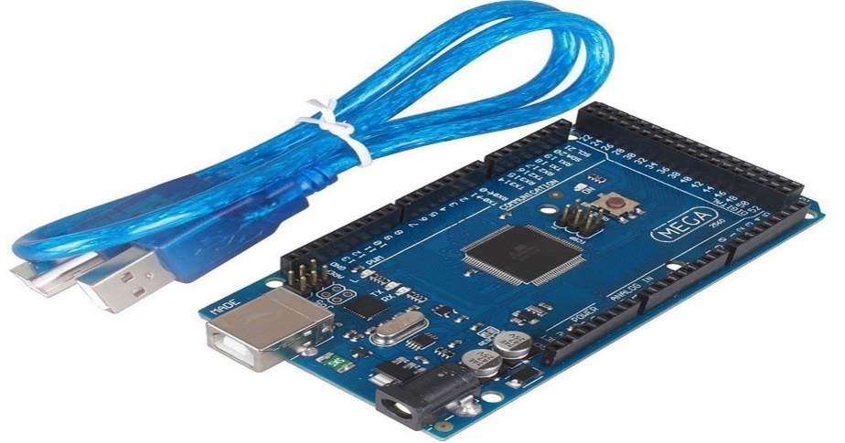

Fig 1: Arduino Mega

1. Fingerprint Module

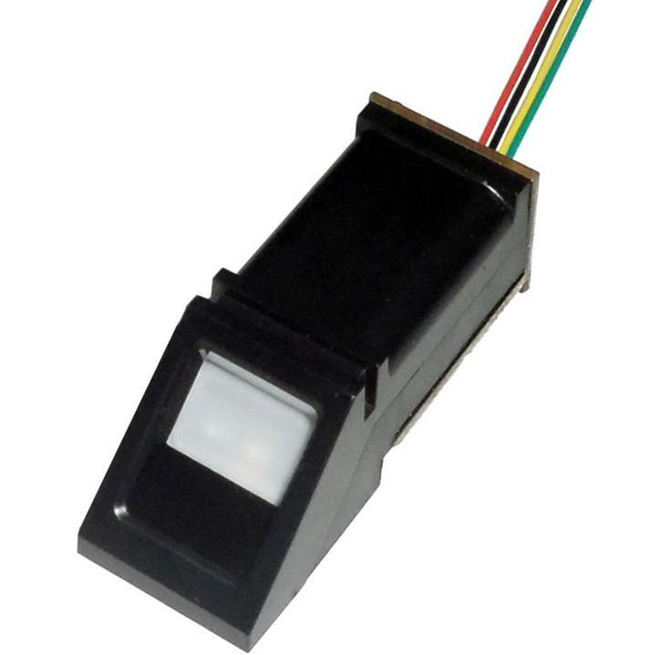

Fig 2: R307 Fingerprint Module

1. Real Time Clock(RTC) Module

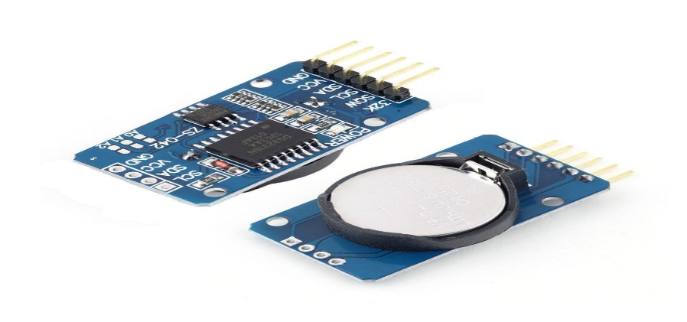

Fig 3: DS3231 RTC Module

1. SD Card Module

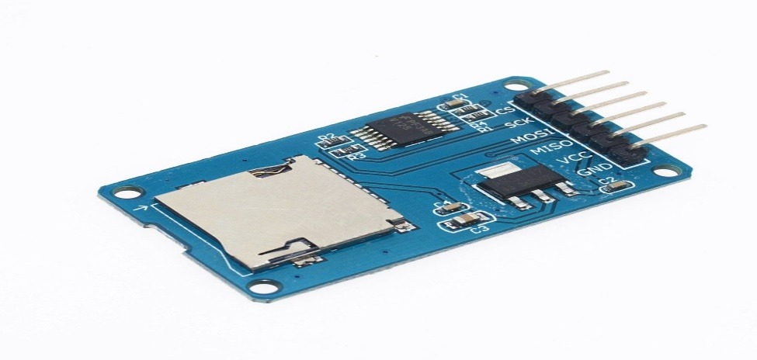

Fig 4: SD Card Module

1. Keypad

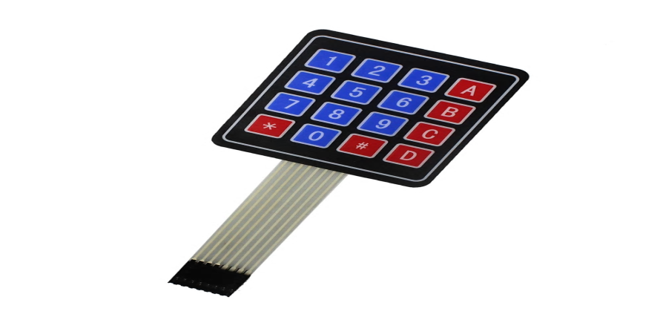

Fig 5: 4*4 Keypad

1. LCD Display

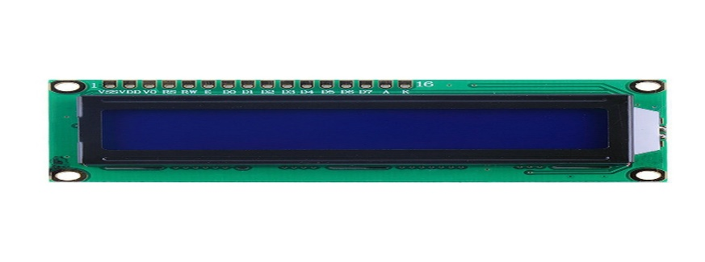

Fig 5: 16*2 LCD Display

1. Potentiometer 8. Card Reader & MicroSD Card
2. Bread Board 10. Connecting wires

**Project Description:**

This proposed system introduces a new automatic attendance management system which integrates fingerprint authentication into the process of attendance management for the students. It consists of 3 processes –

i)Fingerprint Enrollment ii) Taking Attendance iii)Data storage

We have used Fingerprint module to identify a true person by taking his/her finger input in the system. Here we have used 4*4 keypad for setting class date & time and also handling enrolment & attendance processes. RTC module is used for obtaining the current time & date for the fingerprint reader. It can record the exact time when a student attends the class.

**Enrollment:** In the enrollment stage, all the students have to register their fingers against their id numbers. So when the students want to enroll their fingers, they have to press key ‘B’ and then lcd asks for the ID where they want to store their fingers. With the help of key ‘C’ & ‘D’ they can select their IDs and then have to press ‘#’ to proceed with selected ID. Then LCD shows some messages like place finger, remove finger, place same finger again. Maintaining all these steps, fingerprint of the student is captured and its unique features called minutiae points are extracted and is converted into a template and stored by the selected ID into the internal memory of fingerprint module i.e. fingerprint database.

**Taking Attendance:** All the students have to be enrolled before giving attendance. Now the students want to give attendance, they have to press key ‘A’. Then LCD asks for placing finger on the fingerprint module. Then the fingerprint is captured again and the extracted features compared with the template in the database to determine a match before attendance is made. If the fingerprint is not matched lcd shows a message ‘Finger not found’ and if matched, the system will check if matching (student check in time) is made within the first 15 minutes of the class time. If so, the student will be considered as present otherwise it will be a late attendance for him/her. We have used key ‘*’ for back operation.

**Data Storage:** We have used SD card module as interface between SD card and the microcontroller Arduino. It consists of an SD card which is the type of storage used to store the student’s record. Attendance details will be saved in a file (.txt) of the SD card for further purpose. Then we have extracted the data from .txt file to an excel sheet. From the excel sheet, we have calculated the percentage of total attendance of every student. The following figure describes our proposed system clearly -

Finger Not Found

This will save time wasted on calling out

names and it gives a fool-proof method of attendance marking

This will save time wasted on calling out

names and it gives a fool-proof method of attendance marking

Input Course No

No

Process of scanning & searching fingerprint

Setup Class Date & Time

Fingerprint is FOmatched?

Place Finger

Here, s is student check in time & t equals to class starts time + 15 minutes

Yes

s <= t?

Display Date & Time

Press A for Attendance

No

Yes

Present

Late Consideration

Press B for Enrolling new finger

Display Student’s ID on the LCD with a message

Press C or D to select ID & then press # to proceed with selected ID

Finger placed & process scanning started

Stored Finger against ID

Save present ID’s details in SD card

Yes

Press *

No

Back?

Fig 6: Flowchart for our proposed Fingerprint Based Biometric Attendance System

**Block Diagram:**

SD Card Module

Computer

Fingerprint Module(R307)

Arduino Mega

LCD Display

Keypad

RTC Module

(DS3231)

Fig 7: Block Diagram of Biometric Attendance System

**Methodology:**

Figure 7 shows the block diagram of the proposed system. The design combines the microcontroller with the Fingerprint Module, display, and communication interfaces. This integration accelerates development while maintaining design flexibility and simplifies testing. A fingerprint is made of a series of ridges and valleys on the surface of the finger. The uniqueness of a fingerprint is determined by the pattern of ridges and valleys as well as the minutiae points. Minutiae points are local ridge characteristics that occur when a ridge splits apart or a ridge ends.

This system consists of three stages as follows –

1. **Fingerprint Enrollment:**  The following stages are internally maintained in the fingerprint module while enrolling a finger –

* Image Acquisition
* Image Enhancement
* Edge Detection
* Extraction of Miniature points

**Image Acquisition:** Fingerprint image acquisition is considered to be the most critical step in an automated fingerprint authentication system, as it determines the final fingerprint image quality which has a drastic effect in the overall system. Automated fingerprint verification systems use live scan digital images of fingerprints from a fingerprint sensor. These images are used in image enhancement stage.

**Image Enhancement:** In general, due to skin conditions(e.g. dry,wet,bruise etc), sensor noise, incorrect finger pressure and inherent low quality fingers, many fingerprints acquired are of low quality that lead to problems in minutiae extraction. Image Enhancement improves the clarity of ridge and valley structures in the fingerprint images. Histogram equalization method is used for image enhancement.

**Edge Detection:** The purpose of edge detection is to significantly reduce the amount of data found in a fingerprint image and leave only the most important information. Edge detection works by finding points on an image where the gray scale of value changes greatly between pixels. They are many operators used for detecting the edges. The operators are Prewitt, Laplacian, Sobels, Robertson operators. The prewitt operator is one of the best edge detecting operators and it detects two types of edge – horizontal edges & vertical edges. The edges have to be detected in order to match the input image with already saved image. Edges are calculated by using differences between corresponding pixels intensities of an image. All the masks (vertical & horizontal) that are used for edge detection are also known as derivative masks. For vertical mask, it calculates the difference of right and left pixel values around that edge. For horizontal mask, it calculates the difference of above and below pixel intensities of the particular edge. Thus increasing the sudden change of intensities and making the edge more visible.

**Extraction of Miniature points**: After detecting the edges, some points are extracted. These extracted points are known as ‘miniature points’. Most of the minutiae extraction techniques trace the fingerprint skeleton to find different types of minutiae points. After the extraction of edges, the points are marked in it.

1. **Taking Attendance:** In this stage, authentication process is maintained. It is

the most repeated process and it is done each time a student wants to make use of fingerprint module. When he/she places his/her finger on fingerprint scanner surface, the fingerprint will be processed by the scanner. The fingerprint pattern that has been extracted would be compared against the stored enrollment template that is already stored in fingerprint database. When the fingerprint pattern passes the comparison process, it shows a message and allows student’s access. In order to find the matching process the correlation factor and the Euclidean distance has to be found out. Based on the tolerance value the matching results can be found out. The following messages are shown in LCD display after giving attendance –

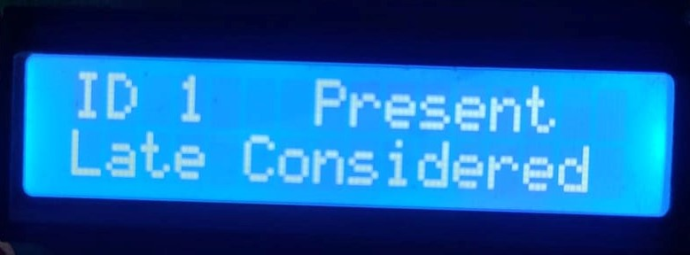 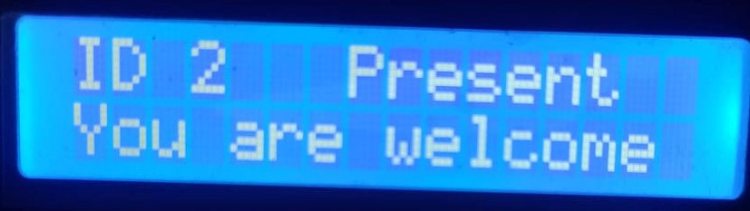

Fig 8(i) – Late Consideration Fig 8(ii) – Within time

We have maintained following rules for marking attendance of a student -

1. Student should scan his/her finger correctly on the fingerprint sensor module. If fingerprint is not putted correctly on reader, it could lead errors. There are two reasons for error - Failure to enroll rate (FTE) and Failure to capture (FTC) rate of biometric device. FTC rate depends on functionality of the system and FTE occur due to poor quality inputs .
2. Students should mark their attendance within 15 minutes of start time of class. For example, if a class starts on 11.30am, attendance will be marked

(present) before 11.45 am. After that time, they will be considered for late attendance. If attendance has already been marked, student is not able to mark another attendance in that lecture.

1. **Data Storage:** All the attendance details will be saved in a file (.txt file) in

SD Card. Here SD Card module is used to interface between arduino and SD card. Then we have extracted the file into excel sheet and from the excel sheet, we have calculated the attendance percentage of each students in different courses and other so.

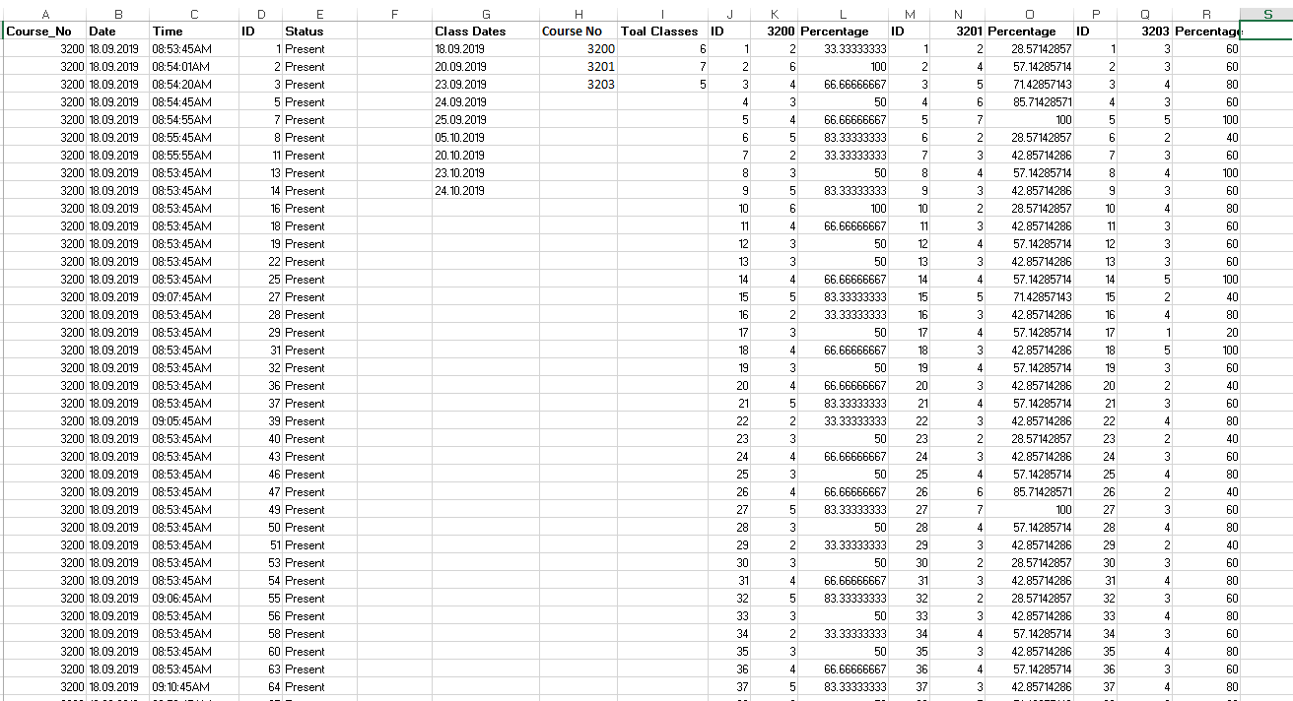

Fig 9: Student Attendance Excel Sheet

**Prototype Design:**

This system has been designed as follows-

Since the sensor wires are so thin and short, we stripped the wire a bit and melted some solder on so it made better contact.

We have used LCD display to show messages. LCD display has 16 pins. Vo pin is connected to the potentiometer. Enable pin(connected to arduino digital pin 12) of the display sends data to data pins when a high to low pulse is given; Extra voltage push is required to execute the instruction and enable signal is used for this purpose. When we send data to LCD it goes to the data register and is processed there. When RS=1, data register is selected. The data register stores the data to be displayed on the LCD.

RTC module is used for obtaining the current time & date for the fingerprint reader. It can record the exact time when a student attends the class. It has 6 pins. 32k & SKW pins are not connected. SDA & SCL pins are connected to the arduino’s SDA & SCL pins respectively.

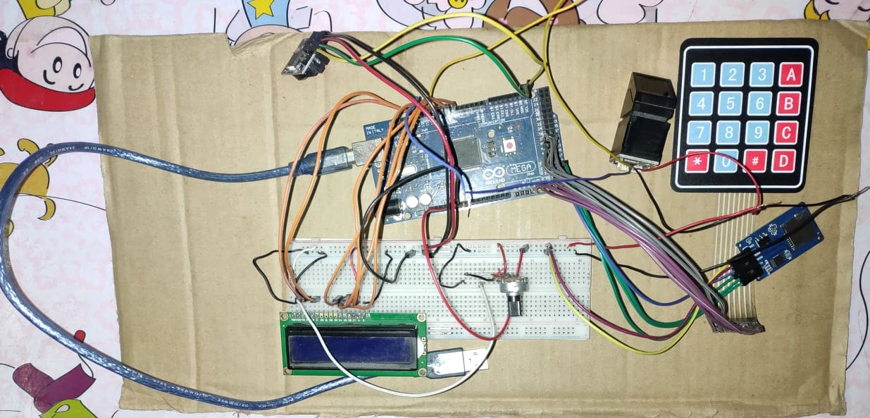

Fig 10: Circuit Design of Fingerprint Based Biometric Attendance System

Fingerprint R307 module is interfaced with the arduino. The students can store fingerprint samples in the module and can be configured in 1:1 or 1:N mode for identification for the right user. It has 4 pins. Tx and Rx pins of the module are connected to arduino digital pins 10 & 11 respectively as shown in figure 10. This connection is used for serial communication only one individual pin is used for transmitter and receiver thus the parallel communication is not possible.

4*4 keypad is also used to take class time & date and course no from the user. Enrollment and attendance process are also handled by the keypad. It has 4 row pins and 4 column pins. Row pins are connected to arduino digital pins 38, 39, 40, 41 respectively and column pins are connected to arduino analog pins A12,A13, A14, A15 respectively.

SD card module is used to save the data. It has 6 pins. CS, SCK, MOSI, MISO pins are connected to arduino digital pins 53,52,51,50 repectively and another two are gnd and vcc pins.

All the gnd and vcc pins of the equipments(like – fingerprint module, rtc module, SD card module, LCD display and potentiometer) are connected to arduino gnd and vcc pins respectively. When all the connections are done, the system has been tested.

**Result Analysis:**

Our proposed system has been tested for a class of 100 students. We have tested with 3 courses in 9 days. Out of the 100 students, some students were not properly identified due to rules (i) (described in Taking attendance section).Other students were properly identified and their attendance was updated. 14 students were 15 minutes late than the class time. According to rules for marking attendance, they are considered as late. The attendance of absent students was not updated. The accuracy of the system are shown in the following table (fig 11)-

|  |  |  |  |  |  |
| --- | --- | --- | --- | --- | --- |
| Class | Total Students | Absent  Students | Successful Identification(s) | Unsuccessful Identification(u) | Accuracy  s/(s+u)% |
| Day 1 | 100 | 28 | 70 | 2 | 97.22% |
| Day 2 | 100 | 23 | 76 | 1 | 98.70% |
| Day 3 | 100 | 32 | 67 | 1 | 98.53% |
| Day 4 | 100 | 28 | 70 | 2 | 97.22% |
| Day 5 | 100 | 30 | 69 | 1 | 98.57% |
| Day 6 | 100 | 21 | 76 | 3 | 96.20% |
| Day 7 | 100 | 31 | 67 | 2 | 97.10% |

Fig 11(i): Accuracy Table

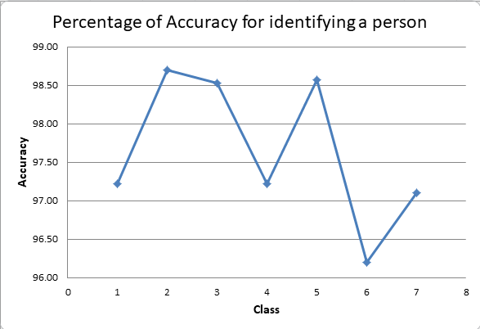 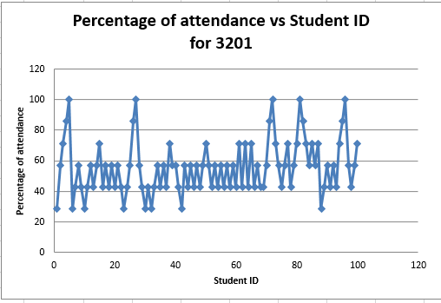

Fig 11(ii): Accuracy Graph Fig 12(i):for 3201 course

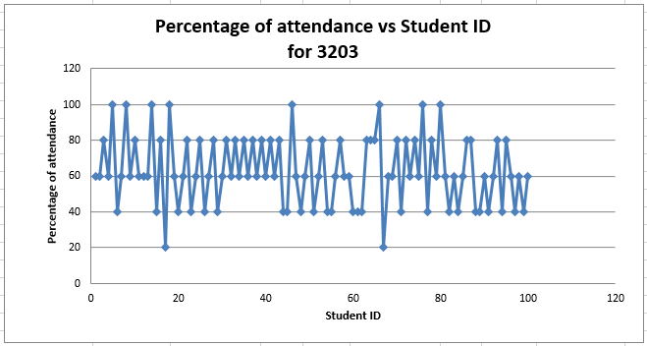 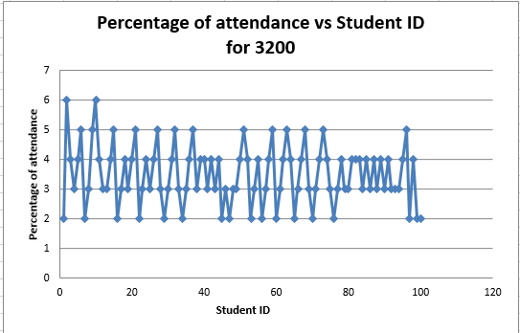

Fig 12(ii): For 3203 course Fig 12(iii): For 3200 course

In Figure 12( i,ii,iii ), attendance percentage of every student in different courses are shown.

**Limitations:**

The limitations of our proposed system are as follows –

1. This biometric device does not always read an individuals fingerprint accurately. If a student does not place his/her correct finger in the right spot, the fingerprint module may not read the student’s identification properly.
2. In case of any physical changes in finger, our system fails to identify the student accurately.
3. Sometimes the system doesn’t work properly because of loose connections.

**Future Plan:**

Try to overcome all limitations and make some improvements in this project to make it more realistic such as the project can be extended to store the attendance details in database on the server and a website will be hosted on the server so that attendance details along with academic details will be visible to a student. The system may also be designed with IOT so that the authority can keep the parents informed about the student’s performance via SMS alerts.

**Conclusion:**

An applicable attendance system has been designed for educational organizations in this project. If this project can be designed practically, it would help to reduce many issues such as denying the possibilities of cheating in recording the attendance, help to ease the lecturers to keep track of student’s attendance, there will be no anonymous fingerprint which is able to tamper with the recorded data, and it saves time in taking attendance instead of queuing in a line.

**References:**

1. <https://www.researchgate.net/publication/282749509_Design_and_development_of_portable_classroom_attendance_system_based_on_Arduino_and_fingerprint_biometric>
2. https://bestengineeringprojects.com/fingerprint-attendance-system-using-arduino/
3. <https://randomnerdtutorials.com/guide-to-sd-card-module-with-arduino/>
4. <https://www.instructables.com/id/Real-time-clock-using-DS3231-EASY/>
5. <https://www.maxphi.com/4x4-membrane-keypad-arduino-interfacing-tutorial>
6. <https://electronicsforu.com/resources/learn-electronics/16x2-lcd-pinout-diagram>
7. <https://ijret.org/volumes/2015v04/i02/IJRET20150402038.pdf>
8. <https://www.researchgate.net/publication/235598499_RFID-Based_Students_Attendance_Management_System>
9. <http://www.mm.media.kyoto-u.ac.jp/old/research/doc/682/FRLASinAEARU.pdf>
10. Kadry, S. and M. Smaili. 2010. “Wireless Attendance Management System Based on Iris Recognition